Moving colliders tutorial

This shows how to move colliders in front of other colliders.

1. Create a new scene

Start by creating a scene called moving colliders.

Add a collider called failCollider & inside but a tiny gap away from the edge of the failCollider that whatever you want will fall onto (beyond the scope of this tutorial) add another collider and call it successCollider.

Make sure that the failCollider and successCollider both have the is Trigger tick box checked.

Example of the colliders:

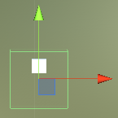

1. Scripting

Create a new C# script called MovingColliders.

This script will allow us to move the success collider in front of the fail collider.

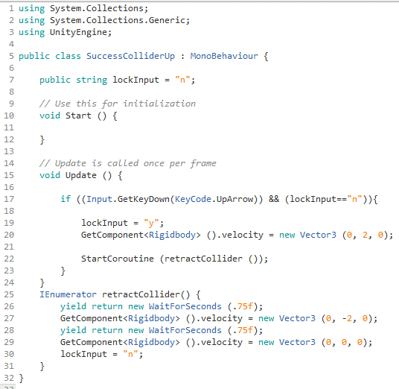

The lock input is to make sure the successCollider (when the up arrow is pressed repeatedly) returns to its original position and doesn’t end up out of place in front of the failCollider when the up arrow key is no longer pressed.

1. Attaching the script and components

Now after saving the script switch back to the Unity editor.

Attach the MovingColliders script to the successCollider.

Run the scene and press the up arrow key, the collider should move up.